[TC-MR12-53] Official Quote Automation – “Keywords” field

is single value

Result: BUG
Reason: The Official Quote can be filled in/updated with any values, other than the ones from the predefined list.
Add Keyword Steps
1. Type in "TEST" keyword ( not in the list)
2. Click "OK". Result: the form is saved with keyword "TEST" (should not be allowed)
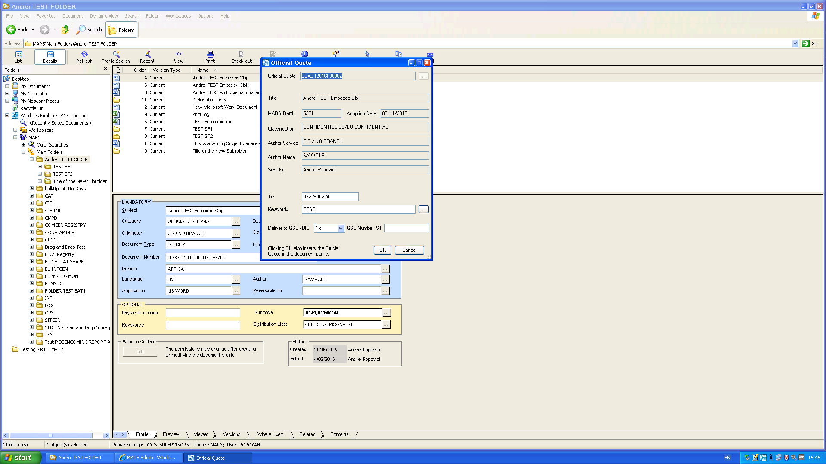

Update Keyword Steps:
1. Selected an Official Quote for update (HR-COM (2016) 00004).
2. Deleted previous keyword.
3. Typed in "TEST".
4. Clicked "OK". The Official Quote was updated to "TEST".
